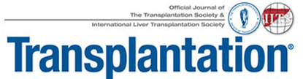

1. SELECT AWARD

______ | Leslie B. Brent Award for the most outstanding paper published in Transplantation in the field of Basic Science research
______ | Anthony J Monaco Award for the most outstanding paper published in Transplantation in the field of Translational Science research

2. Details about the article in Transplantation

Volume # :
Issue #:
doi:
Manuscript Title:
Corresponding Author:

3. Short Overview (not more 250 words) on why this article should be considered.

4. Nominator Full Name:

5. Nominator Email:

Send the application to mailto:awards@tts.org

